SUMPTER CITY OUTDOOR FLEA MARKETS
2024

Memorial Day Weekend – May 24 – 27*
Fourth of July Weekend – No market at the Grounds
Labor Day Weekend – August 30 to September 2*
*Markets Close at 1:00pm on Monday [with limited vendors].
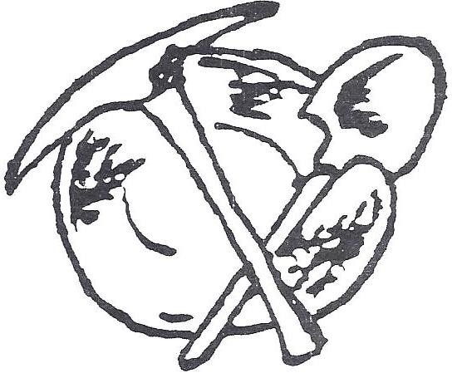
Food, Crafts, Art, Collectibles, New Merchandise, Books and More!
Sales Hours, 8am until Dusk
Admission is Free!

For Vendor Reservations, visit:
Cityofsumpteror.com – Community [tab] – Markets

Or Contact:
Sumpter City Hall
240 Mill St., PO Box 68
Sumpter, OR 97877
541-894-2314
cityofsumpteror@gmail.com

